The Source

Team: Alia, Matteo, Rafa, Vincent, Yann

————————————————————————————————————————

Young Social Entrepreneurs Programme (YSE)

* Singapore xxx fond

[russ@socialcoollider.com](mailto:russ@socialcoollider.com)

WA: 91803710

Notes Rusydi

rusydi.reactor.school

<https://www.ycombinator.com/rfs/>

What will Jury look out for:

* Desirability
* Feasibility (Prototype)
* Viability (Business Model Canvas)
  + Can we make returns? every 1$ → 1.10$ back?

Question on product:

What pain are you solving?

Define your customer

Can customers buy your product today?

prototyping: marvelapp

test key three screens that provide most value

prototype monetary screens and test them in the market

————————————————————————————————————————

### Problem Assumption

The assumption is that news organizations have ulterior motives that may clash with the relaying of unbiased information. Or that people **think** that news organizations are biased.

Version: 10 words or less

I don’t trust the news to relay information without an alternative agenda

Version: 100 words or less

————————————————————————————————————————

Problem Validation

#### Questions:

1. What do you X
2. Why do you Y
3. Do you read the news?
4. Where do you get your news from? What medium do you use? Offline? Online? Websites? Social media? insta bloomberg fb newspaper
5. What kind of news are you interested in? economics, sports,
6. What challenges do you encounter when reading the news? What’s not ideal? premium, articles copies of each other , need to pick the right article
7. How do you address those challenges? you read the article, no real method
8. When was the last time you tried to solve this problem?everyday
9. How did you find your current solution?
10. What emotions do come up when you think about reading the news? disappointment
11. What do you do to diversify your opinion and get other views on topics? / When you read about a topic that matters to you, do you seek multiple sources and perspectives on that topic? read multiple articles to have more opinions
12. If so, how do you find the multiple sources? How do you compare them?google search
13. How do you assess the reliability of the sources you read? newspaper names known to have a bias, format of the source
14. Can you give me some examples of sources you find particularly reliable and not reliable? financial times, economist, bloomberg, big newspaper
15. Do you know anyone else who faces a similar problem?
16. Can we reach out to you when we build a solution to your problem?

IDK where to put: What's the hardest part of gathering world wide news?

Can you tell me about the last time you experience this

Why was it particularly difficult?

What, if anything, have you done to solve this issue?

What don’t you like about the solution you tried?

Do you know anyone

Interviews :

* Talk to industry experts?
* Professor in Media Studies
* Average news customers

Target segment :

### 

### ————————————————————————————————————————

### Solution:

* Legit Problem
* Who is going to p

We hope to provide a solution that relays information directly from the source press release, be it a government or company, such that there is only one layer of bias (the source’s bias). No intermediary opinions or profit driven motives to sift through.

Social impact measurement

* theory of change

ESG certification will generate more corporate support/revenue

only sell to those who agree in the mission

Creating an advisory board

### ————————————————————————————————————————

### About Us:

We are a team of university students coming from business and technical backgrounds. We recognize our own inherent political, economical and social biases, which all clash with one another, except for our one core pillar:

Empowering critical thinking.

In order to achieve this, we have partnered to form TheSource.Press, which through its proprietary unbiased algorithm, sources and identifies the biases inherent in media press and allows for the conscious exploration of opinionated news.

We acknowledge that media sources we link to have their own biases. We do our best to inform you before you enter, but there are always confounding factors. Our goal is to be purely a platform to aggregate information and news, some with stronger biases than others, so you can have the resources to form your own opinions and be critical of other opinions.

You can contact us at info@thesource.press.

### ————————————————————————————————————————

### Our Bias:

Although news bias is inherently political, its measurement need not be.

In developing our own proprietary machine learning algorithm, we draw heavily from the automated unsupervised machine learning technique developed by MIT Researchers [Samantha D'Alonzo](http://sdalonzo@mit.edu) and [Max Tegmark](mailto:tegmark@mit.edu).

However, we use [Principal Component Analysis (PCA)](https://www.tandfonline.com/doi/abs/10.1080/14786440109462720) instead of [Singular Value Decomposition (SVD)](https://doi.org/10.1007%2FBF02288367). The steps for developing the Nij phrase-article pairs are reproducible thanks to the authors making available [*the source*](https://space.mit.edu/home/tegmark/phrasebias.html). You can fact check our understanding below. *

This method is as unbiased as it can be, since it draws only from the data to infer the distribution of news sources. There is no human intervention, nor human correcting. The algorithm finds the key phrases that describe the news landscape (on its own) and assigns (on its own) the companies to each phrase based on the average frequencies of phrase occurrences.

We acknowledge that media sources we link to have their own biases. We do our best to inform you before you enter, but there are always confounding factors. Our goal is to be purely a platform to aggregate information and news, some with stronger biases than others, so you can have the resources to form your own opinions and be critical of other opinions.

* To explain what they did you can read from [The Source](https://arxiv.org/pdf/2109.00024.pdf) itself, and verify our understanding below. In late 2021, drawing from 3,078,624 articles published by 100 media sources (from the largest US newspapers to a broad diversity of political stances), the researchers used a technique called [Singular Value Decomposition (SVD)](https://doi.org/10.1007%2FBF02288367) to derive the key phrases (i) found in the article corpus. Rather than minimizing the [Mean Squared Error Loss (MSE)](https://en.wikipedia.org/wiki/Mean_squared_error) of SVD because it implicitly gives equal weight to fitting every phrase-article pair (Nij, e.g. police↔CNN), they maximize the [Poisson likelihood](https://statlect.com/fundamentals-of-statistics/Poisson-distribution-maximum-likelihood), which aims to find the likelihood a phrase-article pair exists in a news article (j). Finally they add an activation function ([ReLU](https://en.wikipedia.org/wiki/Rectifier_(neural_networks)), [exp](https://en.wikipedia.org/wiki/Exponential_function)) to make sure the pair likelihoods are not negative, which doesn’t make sense in language.

Once the list of phrase-article pairs are generated, they first extract the 10,000 most common phrases. Then, they purge monograms that appeared in a particular bigram more than 70% of the time and all bigrams that appeared in a particular trigram more than 70% of the time. For the BLM topic, for example, “tear” was deleted because it appeared in “tear gas” 87% of the time. One last filtering is done for relevance, uniqueness, specificity, edge cases and identifiable subtopics.

Finally, they map the the pairs on a 2D plot where the X-axis represents Left↔Right and the Y-axis represents Pro-establishment↔Anti-establishment. We show an example of this below. In many cases, we see that such phrase groupings can be viewed as falling on a [linguistic valence spectrum](https://en.wikipedia.org/wiki/Valency_(linguistics)) from positive (euphemism) to neutral (orthophemism) to negative (dysphemism).

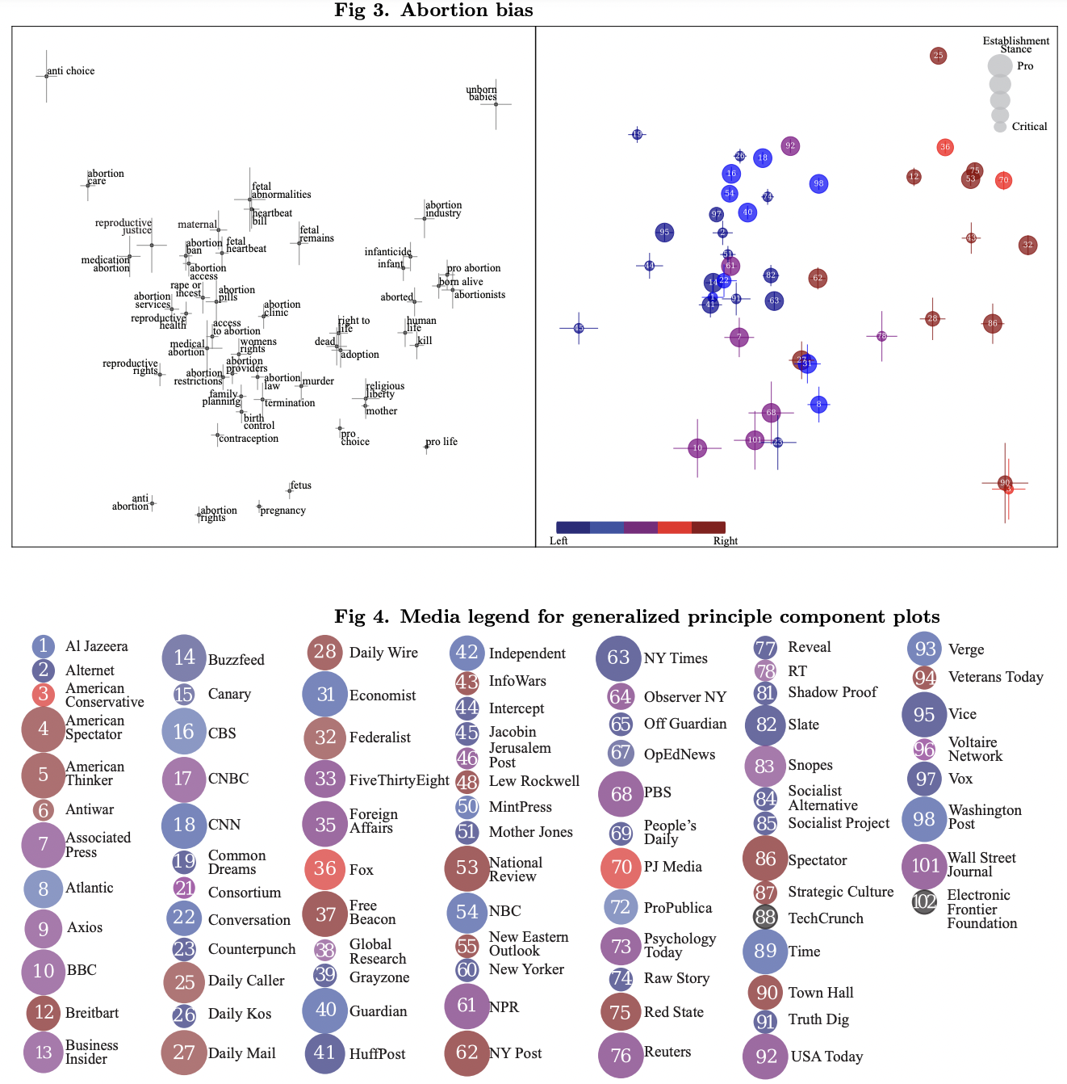

<https://arxiv.org/pdf/2109.00024.pdf>

Pitch:

Where do we fit in? Which Market

What do these numbers mean to us? Empathy towards investors, how do they know what we are doing.

Use numbers that we understand

Bring it home:

* dont keep selling the dream
* not huge numbers, do small numbers from target market
* i talked to 10 people and 8 people said this, xxx didnt like it because xxx
  + include quotes and feelings
* “Use your numbers to tell your story”
* who what how??
* How are we selling to audience, how charge audience (freemium in beginning then charge them later)
  + Dont leave them guessing, say the exact plan and the future plans
* who are them serving to?
* get the basics right first - before introducing the competition

WHO WHAT HOW

* you want to have research to help you introduce your pitch
* drive more on emotions
* sell dreams **AND** solutions

**are we investable? is the idea investable?**

* what you want to avoid!!!
  + as i have said…
  + as i have told you…
  + dont make people feel dumb - be more like “im happy answer that”

### Business Model Canvas

| **Key Partners**  Governmental press releases  Company Press Release  Education Institutions  Newspapers  Investor Relations Websites (IR) | **Key Activities**  Webscraping  Automated bias detection  Newspaper Tracing | **Value Proposition**  Increase awareness of source information  Eliminate bias by giving people  Generate insights and be on top of relevant news  Centralize sources and news articles for convenient  convenience, reliable, bias-free | **Customer Relationship**  Transparency  Trust  Diversity of Content  Non-politicized | **Customer Segments**  18-54 people looking for unbiased and unrefined facts  People who want to broaden their horizon on news topics |
| --- | --- | --- | --- | --- |
| **Key Resources**  Algorithm  Website Developer  Business Developer | **Channels**  Website  Email  Word of Mouth  Instagram / Facebook |
| **Cost Structures**  Technology platform, marketing, server hosting and maintenance, administrative costs | | **Revenue Streams**  Periodic B2B Insights Memo  Tips  Ads | |